**Reflections on project results**

Feel:

The activity teaches us step by step to achieve the final goal:Create the IABC Regina website. It gives us a good experience and we learn a lot of knowledge. First,we know how to divide the final goal into different parts in the story map, we set our first MVP here. Second, we know how to use adobe XD to build the low-fi prototypes. Third, we can use adobe XD more skillfully and use it to build the high-fi prototypes.At last, we learn how to use the wordpress to achieve our high-fi prototypes into the website.Every time we talk with IABC customers and they give us feedback to make our production get improved. This experience is very useful for us when we get to work. The only thing we dislike is that: the wordpress is too complicated. There are so many buttons we don’t know how to use them.So we didn't achieve our goal 100%. It is one point of regret.

Current project:

We listened to the opinion of our customers and tried our best to make our users use our website expediently.And we also use many interesting designs such as events calendar, career login and so on.

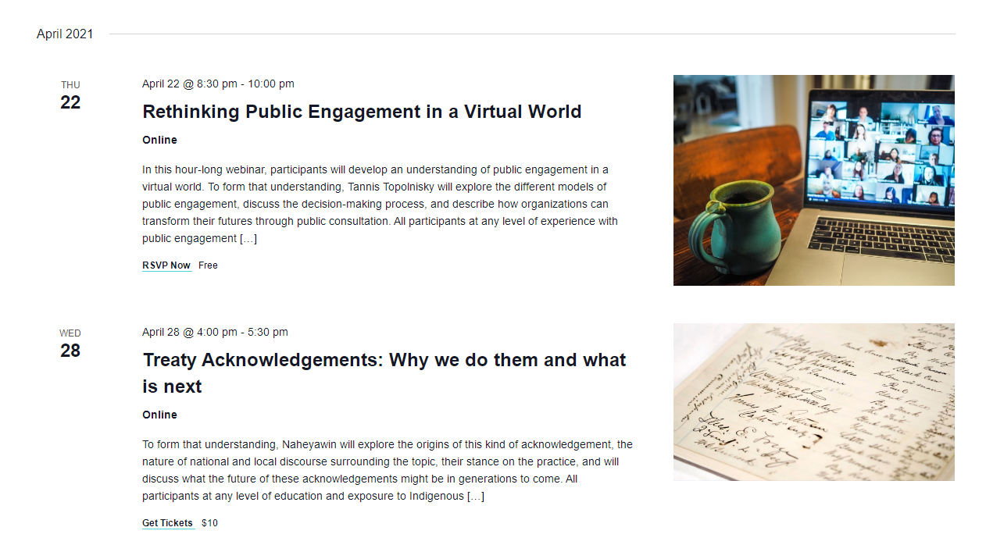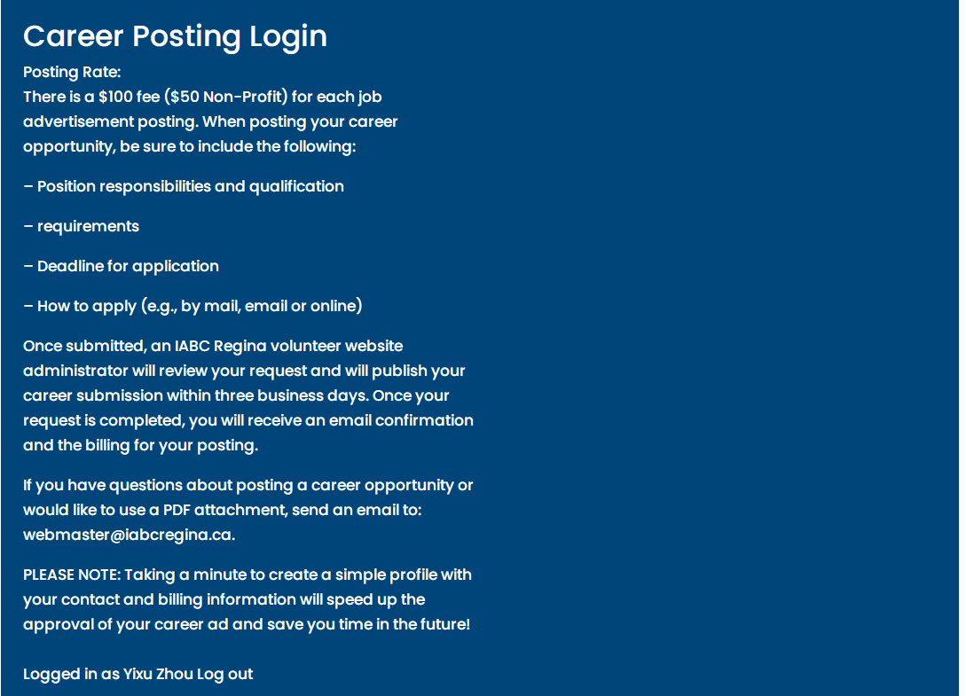

We almost translated all of the prototypes into the wordpress, but we didn’t achieve the community 100%.There are still some buttons in the wordpress which we didn’t know how to use.

Affordance:We try to make our website have a good understanding, the interface is simple to be used. And we also put many texts to tell users how to use those buttons.

signifier:We try to make our website have a good discoverability, users can fully interact with our website with those buttons.For example: show more , show less, go to the forum and so on.

Future project:

Same:

We will first divide the goal into different parts and set the MVP.Then, we will step by step to finish it.

Different:

Before the project, we need to learn how to use the key tool when designing our production.

Opportunities and design ideas:

We wish our project can be more interactive.